- SanDisk commercial ad
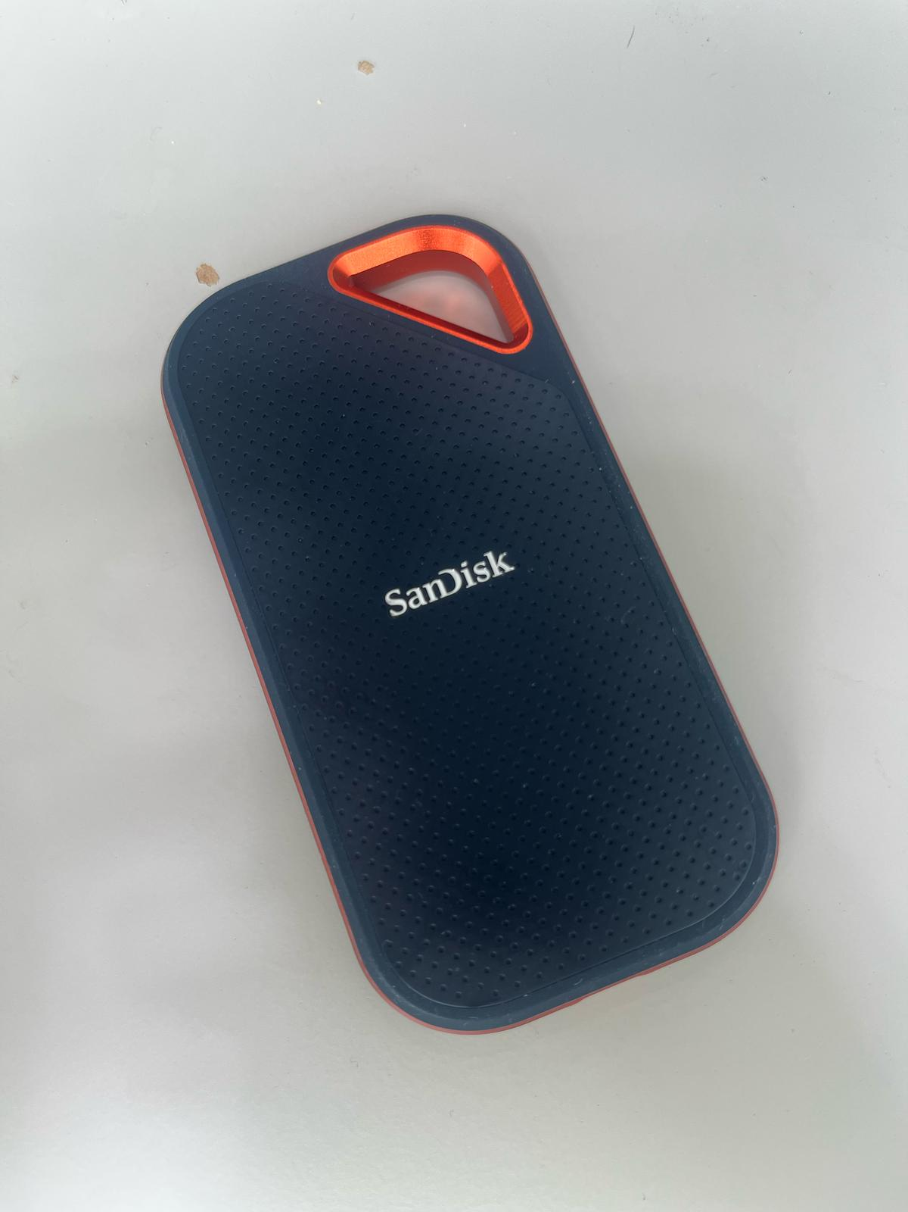
Prompt 1: Create a commercial of this 2TB SSD Sandisk A design image. And add the price tag 199USD
Prompt 2: Take reference to this style
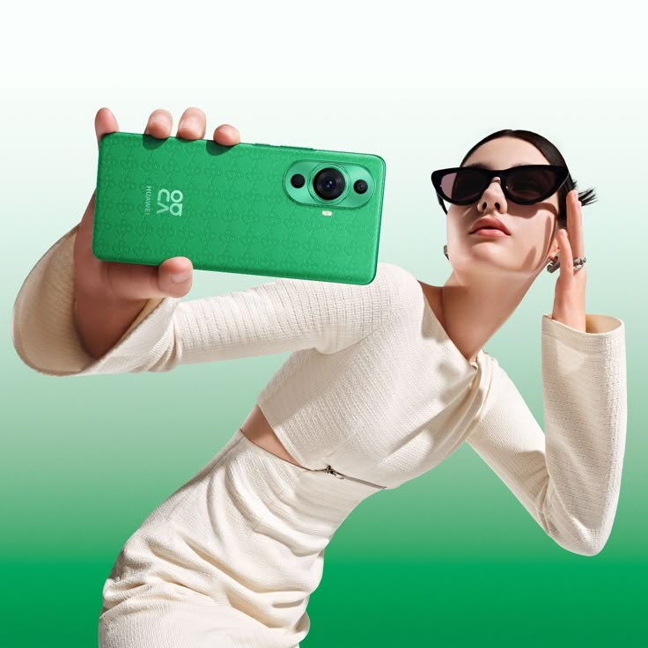
- F1
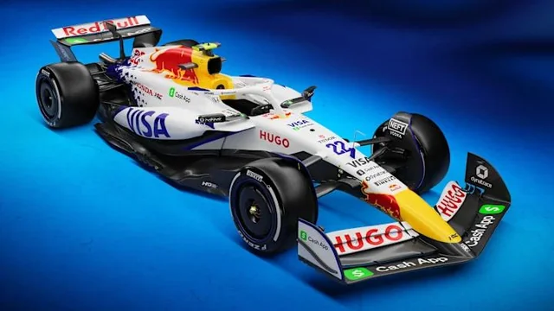
Prompt 1: Change it to comic style
Prompt 2: change it to pixar 3d style
Prompt 3: Change the floor to racing track
Prompt 4: Create a multipanel story of this f1 car accident in the last lap. Position from 1st to 10th
Prompt 5: Generate again in comic style
Prompt 6: Make the story that it win because of the rain
- Japanese Anime Style

Prompt 1: Change this to comic style

Prompt 2: Take reference to this style
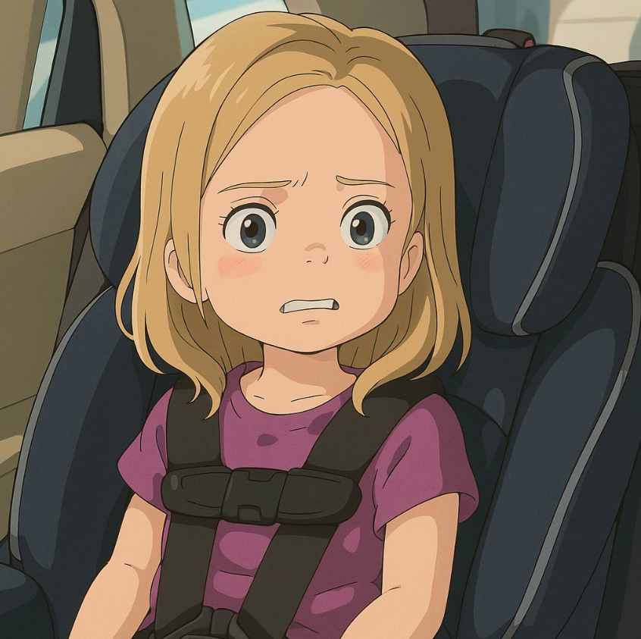

- Comic


Prompt 1: Create a multi-panel comic about Andy sharing AI tools and information on Youtube. You may take reference to the image that is Andy

Prompt 2: The story ended with a lot of community members being able to make money by building their AI businesses

